Wireshark Lab 2: UDP

Group Details:
Ho Seok Lee (1004112177)
Neehar Kantimahanti (1003872286)

Mark:

 | Question | Answer
1 | Select one packet. From this packet, determine how many fields there are in the UDP header. Name these fields. | There are 4 fields.  Source Port  Destination Port  Length  Checksum
Annotated Screenshots  (if needed) | 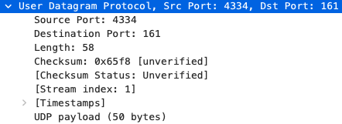
2 | From the packet content field, determine the length (in bytes) of each of the UDP  header fields. | 8 bytes
Annotated Screenshots  (if needed) | 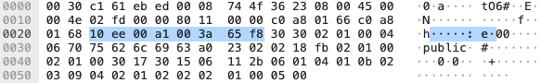
3 | The value in the Length field is the length of what? Verify your claim with your  captured UDP packet. | The length is the length of the packet starting from the header (inclusive).  From the header 00 a1 10 f1 … to 00 04 01 10, there are 58 bytes.
Annotated Screenshots  (if needed) | 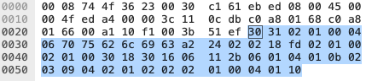
4 | What is the maximum number of bytes that can be included in a UDP payload. | Given that the length field is 2 bytes (16 bits), and the header is 8 bytes, the maximum length is 2^16 – 1 – 8 = 65,527 bytes.
Annotated Screenshots  (if needed) | 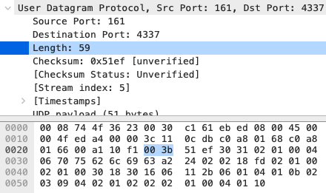
5 | What is the largest possible source port number? | Given that the source port field is 2 bytes (16 bits), the maximum source port number is 2^16 – 1 = 65,535.
Annotated Screenshots  (if needed) | 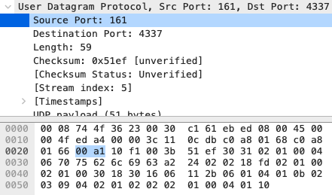
6 | What is the protocol number for UDP? Give your answer in both hexadecimal and decimal notation. (To answer this question, you’ll need to look into the IP  header.) | The protocol number is 17 in decimal and 0x11 in hexadecimal.
Annotated Screenshots  (if needed) | 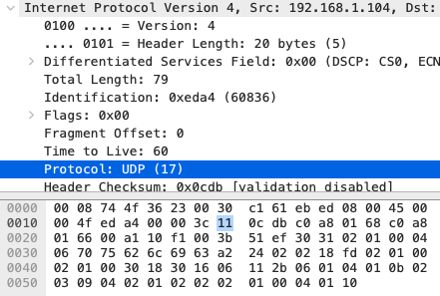
7 | Search “UDP” in Google and determine the fields over which the UDP checksum is calculated. | TCP header: source port, destination port, protocol  UDP header: length
Annotated Screenshots
(if needed)
8 | Examine a pair of UDP packets in which the first packet is sent by your host and the second packet is a reply to the first packet. Describe the relationship between  the port numbers in the two packets | The source port of the first packet is the destination port of the second packet.  The destination port of the first packet is the source port of the second packet.
Annotated Screenshots  (if needed) | 